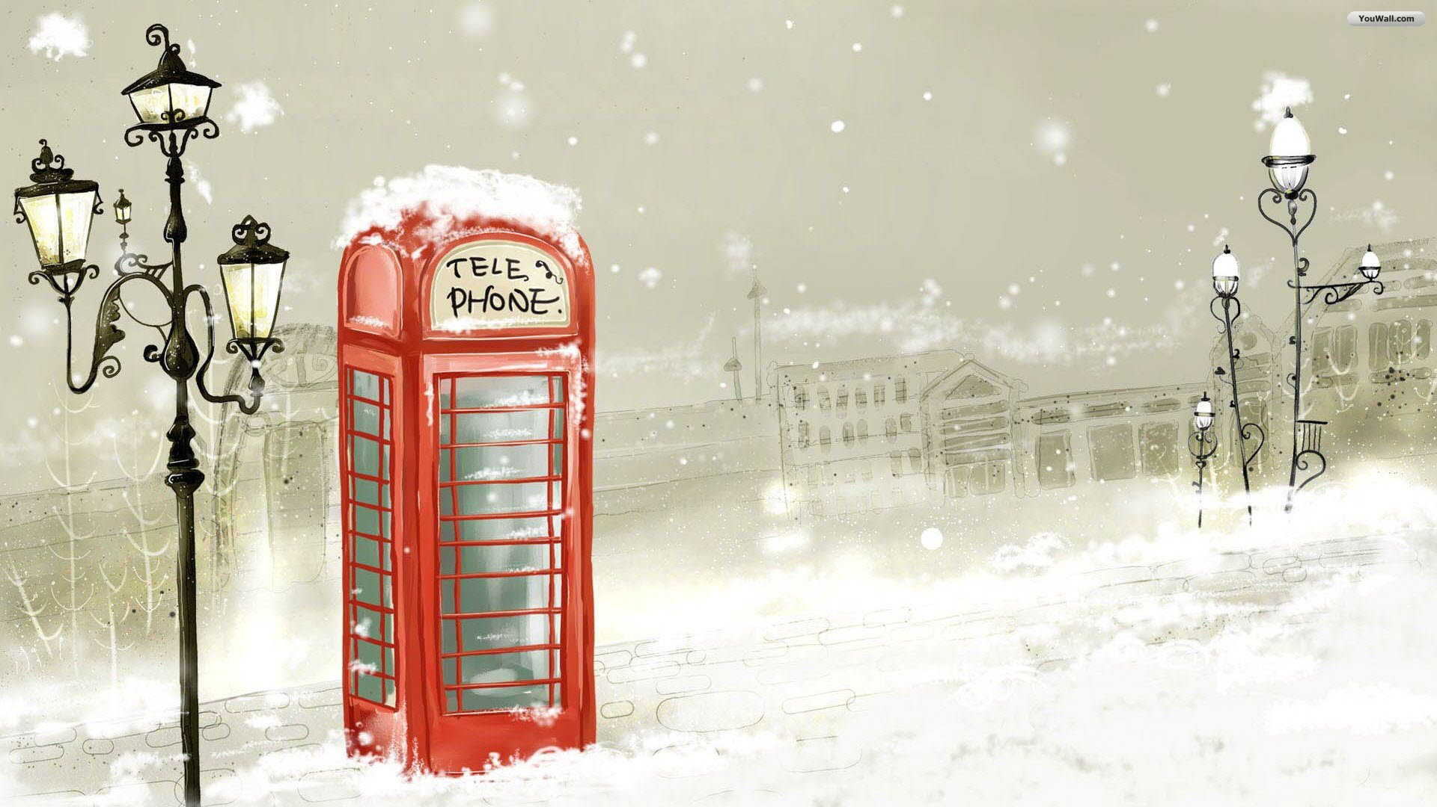
MY ROAD BOOK

DECEMBER 11TH –DECEMBER 16TH
NAME : …………………………………………………………….
Day 1 : (date) ……………………………………………………..

- The host family : (Name) ……………………………………………………………………….

- Where is the house situated ?
…………………………………………………………………...
- Describe some aspects of the house you like:
……………………………………………………………………………………………………………………………
……………………………………………………………………………………………………………………………
- How many members are there in the family ?
……………………………………………………………………………………………………………………………
- Your first British meal
……………………………………………………………………………………………………………………………
- Your room:
● Floor:
● Number of beds :
● Names of your classmates:
……………………………………………………………………………………………………………………………
……………………………………………………………………………………………………………………………
……………………………………………………………………………………………………………………………

● Any comments ?
……………………………………………………………………………………………………………………………
……………………………………………………………………………………………………………………………
……………………………………………………………………………………………………………………………
● ………………………………………………………………………
● ………………………………………………………………………
● ………………………………………………………………………
● ………………………………………………………………………
● ………………………………………………………………………
● ………………………………………………………………………
● ………………………………………………………………………

Day 2 : (date) ……………………………………………………..

- Activities

- Where did we go ? famous monuments ?
………………………………………………………………………………………………
………………………………………………………………………………………………
………………………………………………………………………………………………
………………………………………………………………………………………………

- What did you prefer ? …………………………………………….

- Say why :
………………………………………………………………………………………………
………………………………………………………………………………………………
………………………………………………………………………………………………
………………………………………………………………………………………………

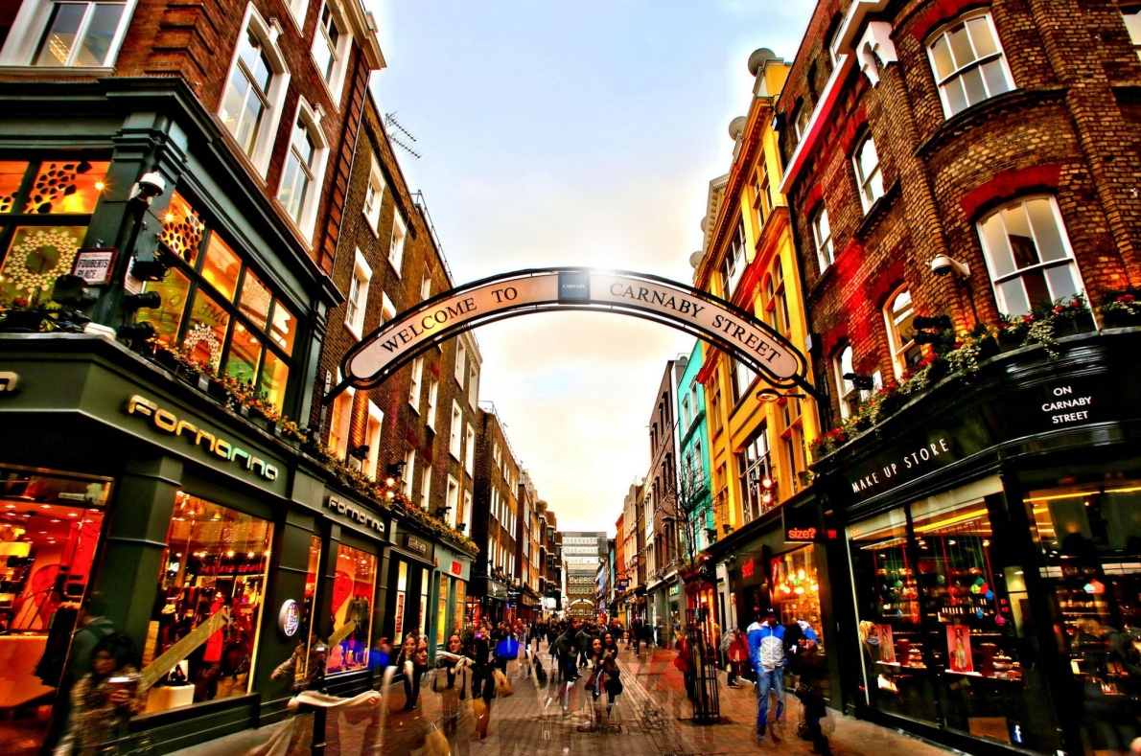
Day 3 : (date) ……………………………………………………..

- Activities

- Describe:
………………………………………………………………………………………………
………………………………………………………………………………………………
………………………………………………………………………………………………
………………………………………………………………………………………………

- What did you prefer ? …………………………………………….

- Say why :
………………………………………………………………………………………………
………………………………………………………………………………………………
………………………………………………………………………………………………
………………………………………………………………………………………………

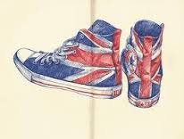

Day 4 : (date) ……………………………………………………..

HARRY POTTER WARNER BROS STUDIOS

- Describe:
………………………………………………………………………………………………
………………………………………………………………………………………………

- What did you prefer ? …………………………………………….

- Say why :
………………………………………………………………………………………………
………………………………………………………………………………………………
………………………………………………………………………………………………
………………………………………………………………………………………………
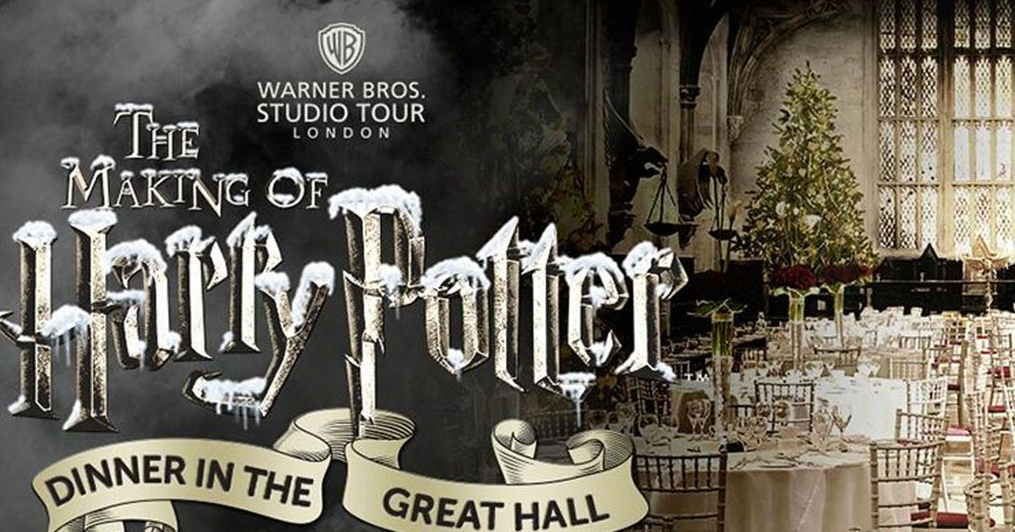

Harry Potter's Christmas - quiz

How many Christmas trees are put in the Great Hall at Hogwarts for Christmas?
12
1
4
25

What hangs from the banisters in Hogwarts castle over Christmas?
Fairy lights
Tinsel
Everlasting icicles
First year students' hats

In The Philosopher’s Stone who got told off for throwing snowballs at Professor Quirrell?
Harry Potter
Ron Weasley
Fred and George Weasley
Draco Malfoy

What did Harry receive from Dumbledore during his first Christmas at Hogwarts?
The philosopher’s stone
The cloak of invisibility
A new wand
Socks

What day did Hermione finish brewing polyjuice potion in The Chamber of Secrets?
Christmas Eve
Christmas Day
Boxing Day
New Year's Day

Who did Harry go to the Yule Ball with on Christmas Day in The Goblet of Fire?
Fleur Delacour
Hermione Granger
Cho Chang
Parvati Patil

What happened to Arthur Weasley just before Christmas in The Order of the Phoenix?
He lost his job
He was attacked by a snake
He slipped over in the snow
He forgot to buy presents and had to give everyone hugs

What present did Harry get from Kreacher in The Half-Blood Prince?
A box of dog biscuits
A firebolt broomstick
A Gryffindor jumper
Maggots

What did the Weasley brothers throw at Percy when he arrived at the Burrow on Christmas day to try to persuade Harry to co-operate with the Ministry of Magic in The Half-Blood Prince?
Mashed parsnip
Mashed potato
Carrots
Turkey

What were Harry and Hermione doing during their last Christmas at Hogwarts?
Sneaking off to Hogsmeade
Revising for their exams
Hiding from Ron
Hunting horcruxes

Harry Potter in London

What are the different places related to Harry Potter you visited in London town centre
- ………………………………………………………………………………………..

Where is it ? …………………………………………….….
Why is it famous ? ……………………………………….
……………………………………………………………………..
……………………………………………………………………..

- ………………………………………………………………………………………..
What is it ?

- ………………………………………………………………………………………..
What is it ?

Lunch and Dinner

- Day 2 :
Name the different dishes

- …………………………………………………………………..
- …………………………………………………………………..
- …………………………………………………………………..

- Day 3 :
Name the different dishes

- …………………………………………………………………..
- …………………………………………………………………..
- …………………………………………………………………..

- Day 4 :
Name the different dishes

- …………………………………………………………………..
- …………………………………………………………………..
- …………………………………………………………………..

- Day 5 :
Name the different dishes

- …………………………………………………………………..
- …………………………………………………………………..
- …………………………………………………………………..
- Day 6 :
Name the different dishes

- …………………………………………………………………..
- …………………………………………………………………..
- …………………………………………………………………..

Dear host family, we would appreciate if you could spare a few minutes to answer the questions on this sheet. Please don't simply fill in this questionnaire; our students are supposed to do this orally, to ask you the questions and to write down your answers. The only purpose of this 'exercise' is to get our students to communicate and to keep them out of their rooms to enjoy a bit of conversation. Thank you very much for your help!

The French group leaders

1- What is your first name? ___________________________
Are you married? ________________
What is your husband/wife's first name? _________________________
What's your job? Your husband/wife's job?__________________________________________

2- Were you born in this town? _____________________
How long have you lived here? _________________________________________
Have you lived in another part of the UK before (if yes, where?) ____________________________________

3- Do you have any children? _________________
Are they married? ___________________
How old are they?________________________________________________________
Do you have any grandchildren? _____________________________________________
Do you have any pets? _____________________________________________________

4- How many TV sets do you own? _____________________________________
What is your favorite channel? TV program? ________________________________

5- Do you have any hobbies? ________________________
Do you like football? ___________
What is your favorite English team? ___________________________

6- Do you often have students staying here? _____________________
How long have you been doing that? _______________________________

7- Have you ever visited France? ___________________________________ Where?_____________________________________
What French food do you prefer? _______________________________________

Mr/Mrs _________________________, thank you so much for answering these questions!!!

If you want to keep in touch with us, please write down your email address !!!!! ☺

AN ENQUIRY IN LONDON

STUDENT 1 ………………………………………… STUDENT 2 ……………………………………………..
STUDENT 3 …………………………………………..

Name of the beauty salon | Street  + Famous place nearby | Underground station  Or bus stop

QUESTIONS :
Hello / good morning / good afternoon , we are French students , we study beauty and cosmetics in France and we would like to ask you a few questions about your job ;
Is it possible ?
- What type / kind of products do you sell ?
- How much do customers spend on average ? What is the range of price ?
- What’s your best seller ?
- How many employees do you have ?
- Do you welcome men and women ?
- Do you sell products for men ?
- What’s your opening days and hours ?
- When was the company created ?
- Do you wear a uniform ? why ?
- What do you need to be employed in that company ?
- Do you like your job ?
Ask for a leaflet … Thank you very much for your time ! have a good day !
Bilan personnel après la visite
- How was the beautician who welcomed you to her beauty salon?
□ Very nice □ Nice □ So, so □ Bad □ Very bad

- Names of beauty salons that refused to welcome you
……………………………………………………………………………………………………
……………………………………………………………………………………………………
……………………………………………………………………………………………………

